NetBeans

1.

a)

Aproximadamente 10 minutos, pero habría sido más de no ser por no haber leído el grupo de clase en el que dijeron que podía hacerse con JFrame y he ido directo a buscar información. (No hemos visto nada gráfico en programación)

b)

Ningún problema destacable, simplemente se trataba de un contenido totalmente nuevo.

c)

Por lo que he visto BlueJ no cuenta con un entorno gráfico para el diseño de ventanas.

d)

No.

Captura)

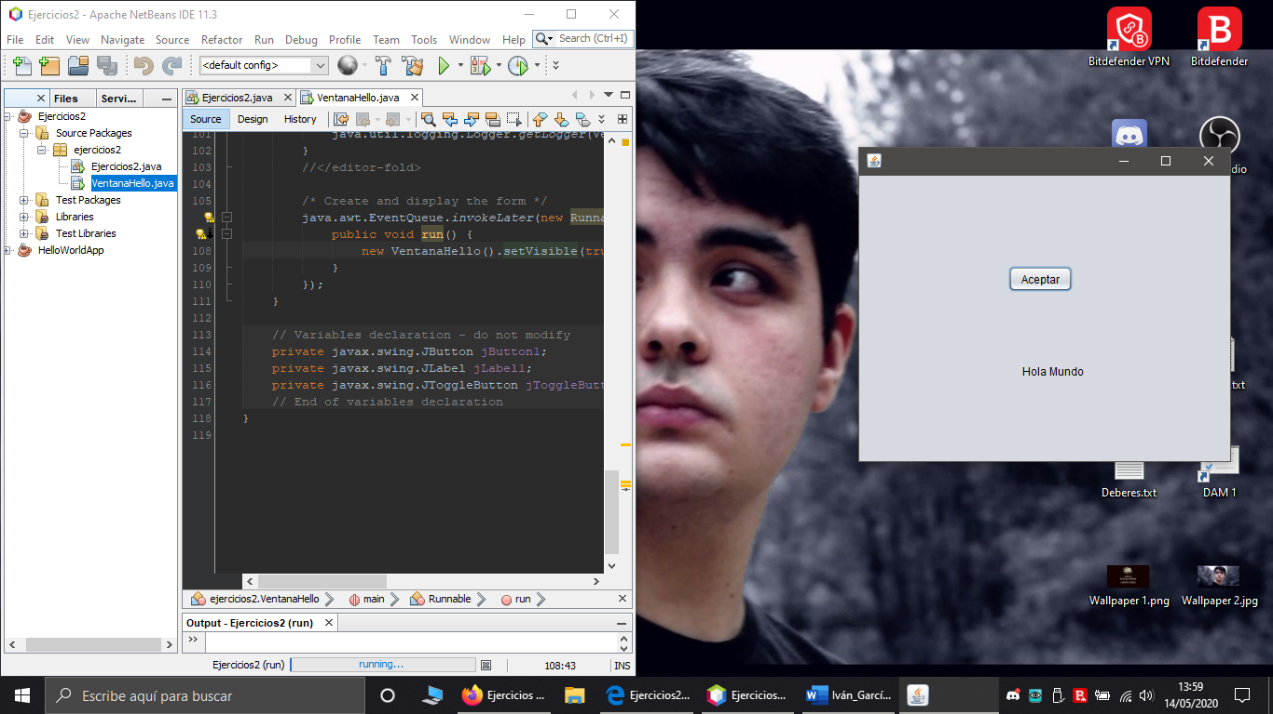

**Código)** Aumentar tamaño de letra para ver.

/*

* To change this license header, choose License Headers in Project Properties.

* To change this template file, choose Tools | Templates

* and open the template in the editor.

*/

package ejercicios2;

/**

*

* @author ivgap

*/

public class VentanaHello extends javax.swing.JFrame {

/**

* Creates new form VentanaHello

*/

public VentanaHello() {

initComponents();

}

/**

* This method is called from within the constructor to initialize the form.

* WARNING: Do NOT modify this code. The content of this method is always

* regenerated by the Form Editor.

*/

@SuppressWarnings("unchecked")

// <editor-fold defaultstate="collapsed" desc="Generated Code">

private void initComponents() {

jToggleButton1 = new javax.swing.JToggleButton();

jButton1 = new javax.swing.JButton();

jLabel1 = new javax.swing.JLabel();

jToggleButton1.setText("jToggleButton1");

setDefaultCloseOperation(javax.swing.WindowConstants.EXIT_ON_CLOSE);

jButton1.setText("Aceptar");

jButton1.addActionListener(new java.awt.event.ActionListener() {

public void actionPerformed(java.awt.event.ActionEvent evt) {

jButton1ActionPerformed(evt);

}

});

jLabel1.setText("Mensaje");

javax.swing.GroupLayout layout = new javax.swing.GroupLayout(getContentPane());

getContentPane().setLayout(layout);

layout.setHorizontalGroup(

layout.createParallelGroup(javax.swing.GroupLayout.Alignment.LEADING)

.addGroup(layout.createSequentialGroup()

.addGroup(layout.createParallelGroup(javax.swing.GroupLayout.Alignment.LEADING)

.addGroup(layout.createSequentialGroup()

.addGap(160, 160, 160)

.addComponent(jButton1))

.addGroup(layout.createSequentialGroup()

.addGap(175, 175, 175)

.addComponent(jLabel1)))

.addContainerGap(169, Short.MAX_VALUE))

);

layout.setVerticalGroup(

layout.createParallelGroup(javax.swing.GroupLayout.Alignment.LEADING)

.addGroup(javax.swing.GroupLayout.Alignment.TRAILING, layout.createSequentialGroup()

.addGap(97, 97, 97)

.addComponent(jButton1)

.addGap(77, 77, 77)

.addComponent(jLabel1)

.addContainerGap(89, Short.MAX_VALUE))

);

pack();

}// </editor-fold>

private void jButton1ActionPerformed(java.awt.event.ActionEvent evt) {

jLabel1.setText("Hola Mundo");

}

/**

* @param args the command line arguments

*/

public static void main(String args[]) {

/* Set the Nimbus look and feel */

//<editor-fold defaultstate="collapsed" desc=" Look and feel setting code (optional) ">

/* If Nimbus (introduced in Java SE 6) is not available, stay with the default look and feel.

* For details see http://download.oracle.com/javase/tutorial/uiswing/lookandfeel/plaf.html

*/

try {

for (javax.swing.UIManager.LookAndFeelInfo info : javax.swing.UIManager.getInstalledLookAndFeels()) {

if ("Nimbus".equals(info.getName())) {

javax.swing.UIManager.setLookAndFeel(info.getClassName());

break;

}

}

} catch (ClassNotFoundException ex) {

java.util.logging.Logger.getLogger(VentanaHello.class.getName()).log(java.util.logging.Level.SEVERE, null, ex);

} catch (InstantiationException ex) {

java.util.logging.Logger.getLogger(VentanaHello.class.getName()).log(java.util.logging.Level.SEVERE, null, ex);

} catch (IllegalAccessException ex) {

java.util.logging.Logger.getLogger(VentanaHello.class.getName()).log(java.util.logging.Level.SEVERE, null, ex);

} catch (javax.swing.UnsupportedLookAndFeelException ex) {

java.util.logging.Logger.getLogger(VentanaHello.class.getName()).log(java.util.logging.Level.SEVERE, null, ex);

}

//</editor-fold>

/* Create and display the form */

java.awt.EventQueue.invokeLater(new Runnable() {

public void run() {

new VentanaHello().setVisible(true);

}

});

}

// Variables declaration - do not modify

private javax.swing.JButton jButton1;

private javax.swing.JLabel jLabel1;

private javax.swing.JToggleButton jToggleButton1;

// End of variables declaration

}

2.

a)

Dos horas y media.

b)

a)

Dos horas y veintitrés minutos.

b)

Seis minutos.

c)

Un minuto.

Capturas)

Ventana principal:

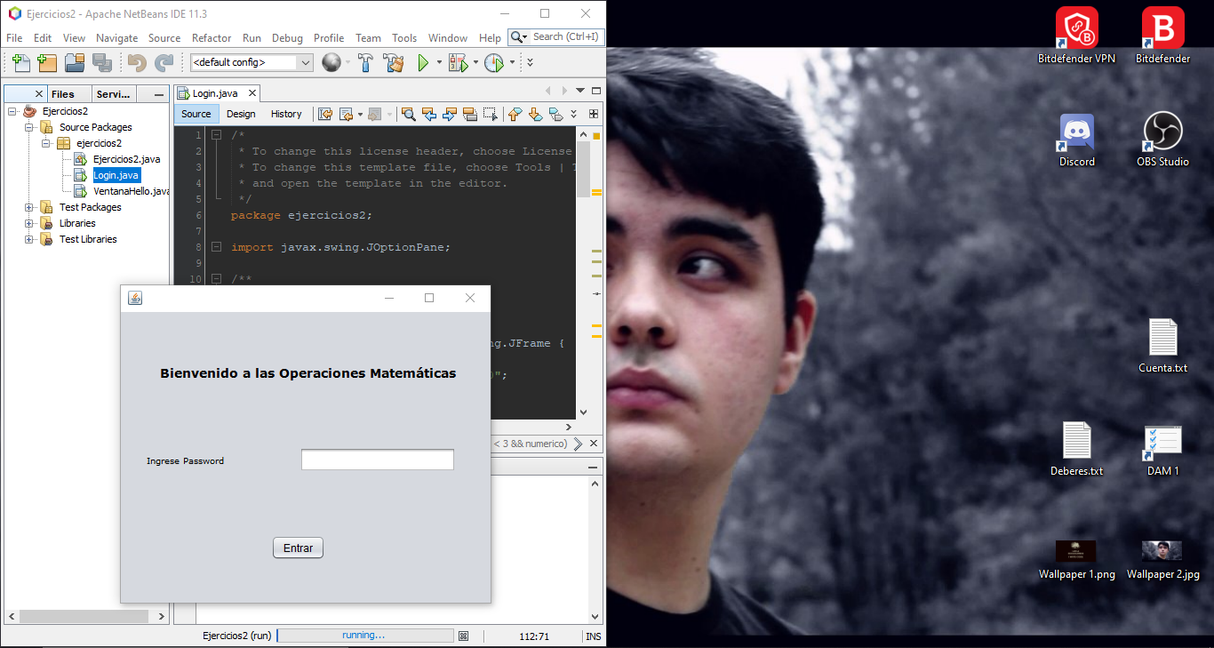

Comprobación de datos numéricos:

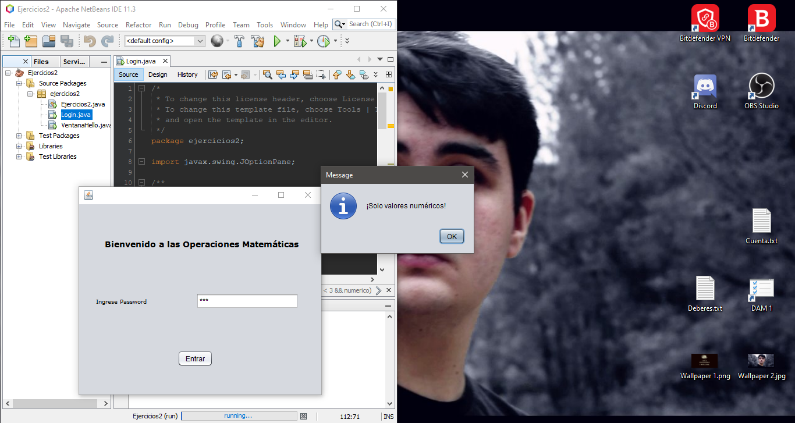

Comprobación contraseña incorrecta:

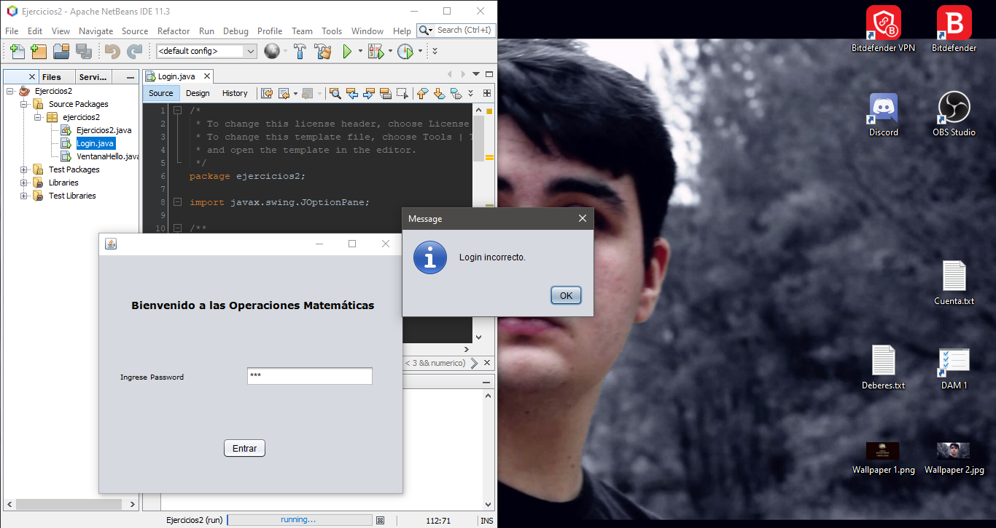

Comprobación de contraseña correcta:

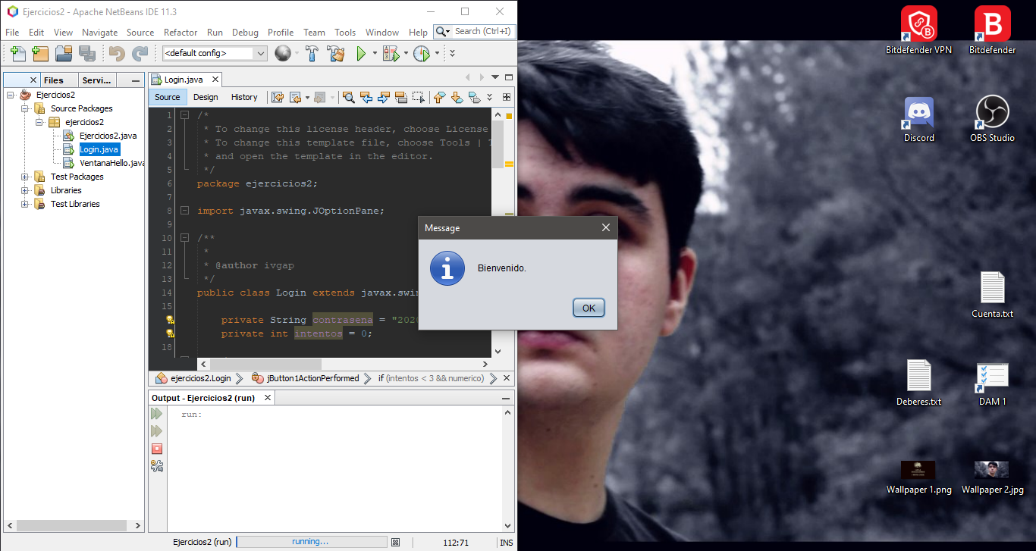

**Código)** Aumentar tamaño de letra para ver.

/*

* To change this license header, choose License Headers in Project Properties.

* To change this template file, choose Tools | Templates

* and open the template in the editor.

*/

package ejercicios2;

import javax.swing.JOptionPane;

/**

*

* @author ivgap

*/

public class Login extends javax.swing.JFrame {

private String contrasena = "2020";

private int intentos = 0;

/**

* Creates new form Login

*/

public Login() {

initComponents();

}

/**

* This method is called from within the constructor to initialize the form.

* WARNING: Do NOT modify this code. The content of this method is always

* regenerated by the Form Editor.

*/

@SuppressWarnings("unchecked")

// <editor-fold defaultstate="collapsed" desc="Generated Code">

private void initComponents() {

jLabel1 = new javax.swing.JLabel();

jButton1 = new javax.swing.JButton();

jLabel2 = new javax.swing.JLabel();

jPasswordField2 = new javax.swing.JPasswordField();

setDefaultCloseOperation(javax.swing.WindowConstants.EXIT_ON_CLOSE);

jLabel1.setFont(new java.awt.Font("Verdana Pro", 1, 14)); // NOI18N

jLabel1.setText("Bienvenido a las Operaciones Matemáticas");

jLabel1.setToolTipText("");

jButton1.setText("Entrar");

jButton1.addActionListener(new java.awt.event.ActionListener() {

public void actionPerformed(java.awt.event.ActionEvent evt) {

jButton1ActionPerformed(evt);

}

});

jLabel2.setFont(new java.awt.Font("Verdana Pro", 0, 10)); // NOI18N

jLabel2.setText("Ingrese Password");

jLabel2.setToolTipText("");

javax.swing.GroupLayout layout = new javax.swing.GroupLayout(getContentPane());

getContentPane().setLayout(layout);

layout.setHorizontalGroup(

layout.createParallelGroup(javax.swing.GroupLayout.Alignment.LEADING)

.addGroup(javax.swing.GroupLayout.Alignment.TRAILING, layout.createSequentialGroup()

.addGroup(layout.createParallelGroup(javax.swing.GroupLayout.Alignment.TRAILING)

.addGroup(layout.createSequentialGroup()

.addGap(29, 29, 29)

.addComponent(jLabel2)

.addGroup(layout.createParallelGroup(javax.swing.GroupLayout.Alignment.LEADING)

.addGroup(layout.createSequentialGroup()

.addGap(53, 53, 53)

.addComponent(jButton1)

.addPreferredGap(javax.swing.LayoutStyle.ComponentPlacement.RELATED, javax.swing.GroupLayout.DEFAULT_SIZE, Short.MAX_VALUE))

.addGroup(javax.swing.GroupLayout.Alignment.TRAILING, layout.createSequentialGroup()

.addPreferredGap(javax.swing.LayoutStyle.ComponentPlacement.RELATED, javax.swing.GroupLayout.DEFAULT_SIZE, Short.MAX_VALUE)

.addComponent(jPasswordField2, javax.swing.GroupLayout.PREFERRED_SIZE, 176, javax.swing.GroupLayout.PREFERRED_SIZE))))

.addGroup(layout.createSequentialGroup()

.addContainerGap(44, Short.MAX_VALUE)

.addComponent(jLabel1)))

.addGap(39, 39, 39))

);

layout.setVerticalGroup(

layout.createParallelGroup(javax.swing.GroupLayout.Alignment.LEADING)

.addGroup(layout.createSequentialGroup()

.addGap(59, 59, 59)

.addComponent(jLabel1)

.addPreferredGap(javax.swing.LayoutStyle.ComponentPlacement.RELATED, 75, Short.MAX_VALUE)

.addGroup(layout.createParallelGroup(javax.swing.GroupLayout.Alignment.BASELINE)

.addComponent(jLabel2)

.addComponent(jPasswordField2, javax.swing.GroupLayout.PREFERRED_SIZE, javax.swing.GroupLayout.DEFAULT_SIZE, javax.swing.GroupLayout.PREFERRED_SIZE))

.addGap(71, 71, 71)

.addComponent(jButton1)

.addGap(48, 48, 48))

);

pack();

}// </editor-fold>

private void jButton1ActionPerformed(java.awt.event.ActionEvent evt) {

String conIntr = jPasswordField2.getText();

boolean numerico = false;

try {

Integer.parseInt(conIntr);

numerico = true;

} catch (NumberFormatException nfe) {

JOptionPane.showMessageDialog(null, "¡Solo valores numéricos!");

}

if (intentos < 3 && numerico) {

if(conIntr.equals(contrasena)) {

dispose();

JOptionPane.showMessageDialog(null, "Bienvenido.");

}

else {

JOptionPane.showMessageDialog(null, "Login incorrecto.");

}

}

}

/**

* @param args the command line arguments

*/

public static void main(String args[]) {

/* Set the Nimbus look and feel */

//<editor-fold defaultstate="collapsed" desc=" Look and feel setting code (optional) ">

/* If Nimbus (introduced in Java SE 6) is not available, stay with the default look and feel.

* For details see http://download.oracle.com/javase/tutorial/uiswing/lookandfeel/plaf.html

*/

try {

for (javax.swing.UIManager.LookAndFeelInfo info : javax.swing.UIManager.getInstalledLookAndFeels()) {

if ("Nimbus".equals(info.getName())) {

javax.swing.UIManager.setLookAndFeel(info.getClassName());

break;

}

}

} catch (ClassNotFoundException ex) {

java.util.logging.Logger.getLogger(Login.class

.getName()).log(java.util.logging.Level.SEVERE, null, ex);

} catch (InstantiationException ex) {

java.util.logging.Logger.getLogger(Login.class

.getName()).log(java.util.logging.Level.SEVERE, null, ex);

} catch (IllegalAccessException ex) {

java.util.logging.Logger.getLogger(Login.class

.getName()).log(java.util.logging.Level.SEVERE, null, ex);

} catch (javax.swing.UnsupportedLookAndFeelException ex) {

java.util.logging.Logger.getLogger(Login.class

.getName()).log(java.util.logging.Level.SEVERE, null, ex);

}

//</editor-fold>

/* Create and display the form */

java.awt.EventQueue.invokeLater(new Runnable() {

public void run() {

new Login().setVisible(true);

}

});

}

// Variables declaration - do not modify

private javax.swing.JButton jButton1;

private javax.swing.JLabel jLabel1;

private javax.swing.JLabel jLabel2;

private javax.swing.JPasswordField jPasswordField2;

// End of variables declaration

}